Greg Watts
221 Hualani St
Kailua, HI 96734
July 12, 2020

Dear Ravasz family:

I hope my letter finds you well and coping with the current crisis. Although we normally visit homes from door to door, we are trying to be safe at this time. We would like to just ask a thoughtful question, ‘What is more important, money...or family? And how can we really DO what we THINK is best?

I wanted to make my neighbors aware of a free online bible study lesson program on JW.ORG. It is called A Balanced View of Money

Did you know that the bible points to a practical, peaceful and happy view of possessions and people? You can also learn to avoid the stress and unhappiness that doing unwise things can bring. (1 Tim 6:10)
Here is a QR code that will take your phone to this information (or you can type in https://www.jw.org/en/library/magazines/g201509/bible-verses-about-money/ )
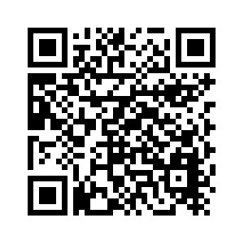
JW.ORG is a free website that does not track those who visit it. Helpful Bible based information is available in over 1,000 languages, including Hawaiian and Hawaiian pidgin. Hope you are able to check it out.
Aloha,

